Smarter Maintenance with the Griffin Toolkit®



Simple and effective maintenance strategies are critical for lowering costs across industries, and the Griffin Toolkit® provides an excellent platform for improving maintenance practices. Condition-based maintenance can replace time-interval or gut-feel based approaches, detecting problems before they cause process upsets or secondary damage. This reduces the overall maintenance burden as well as costs from unexpected downtime. In this pamphlet we look at the user-friendly tools Griffin delivers that can quickly enhance your condition-based and predictive maintenance protocols.

Actual vs. Historical Trending

Detecting departures from expected values is an essential element of condition-based maintenance. Users first create a reference dataset of “normal” operating conditions. Current vibration, power consumption, or other data can then be trended on top of the expected values, as shown below. The first image is data from a wind turbine prior to a failure event. The second example shows a departure from expected fuel flow for a gas burner, indicating a maintenance need. With Griffin, this type of display can be created in seconds, based on existing data and without the addition of new sensors.

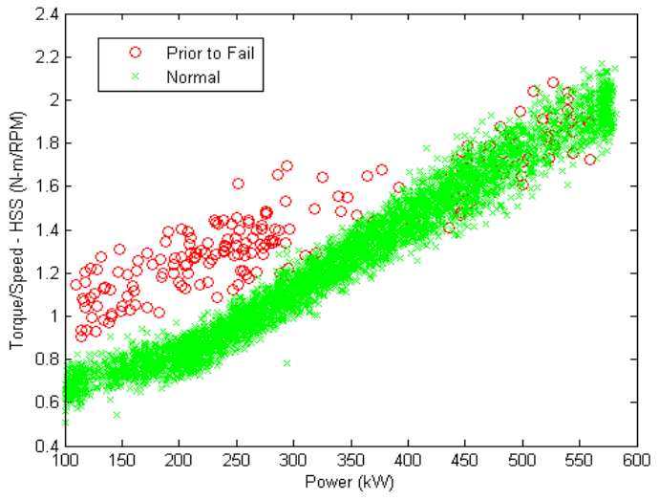 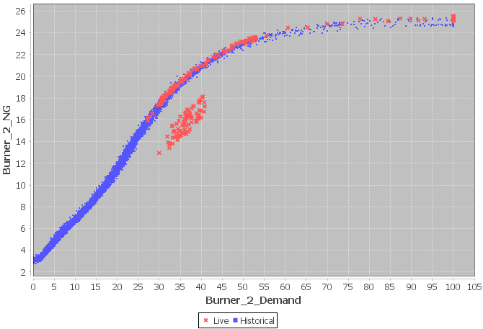

Vibration Monitoring

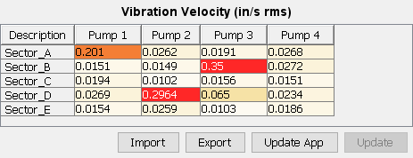If users wish to avoid or supplement onboard vibration sensor alarms, maintenance on multiple types of equipment can be scheduled intelligently by routing vibration data into Griffin, where a maintenance priority can be assigned based on existing [ISO standards](https://www.iso.org/standard/63180.html). Live Griffin displays, such as shown on the right, can be easily created and customized, providing color-coded priority levels to plant personnel.

Post-DCS Alarm Filtering

With the proliferation of equipment monitoring hardware that includes onboard diagnostics and alarm generation (MSET and similar), false positives have become a serious issue. Griffin’s graphical programming environment allows users to quickly develop and deploy alarm filtering logic that can be easily updated in real-time based on experience and best practices. This adds crucial flexibility to DCS systems and black-box solutions provided by other vendors.

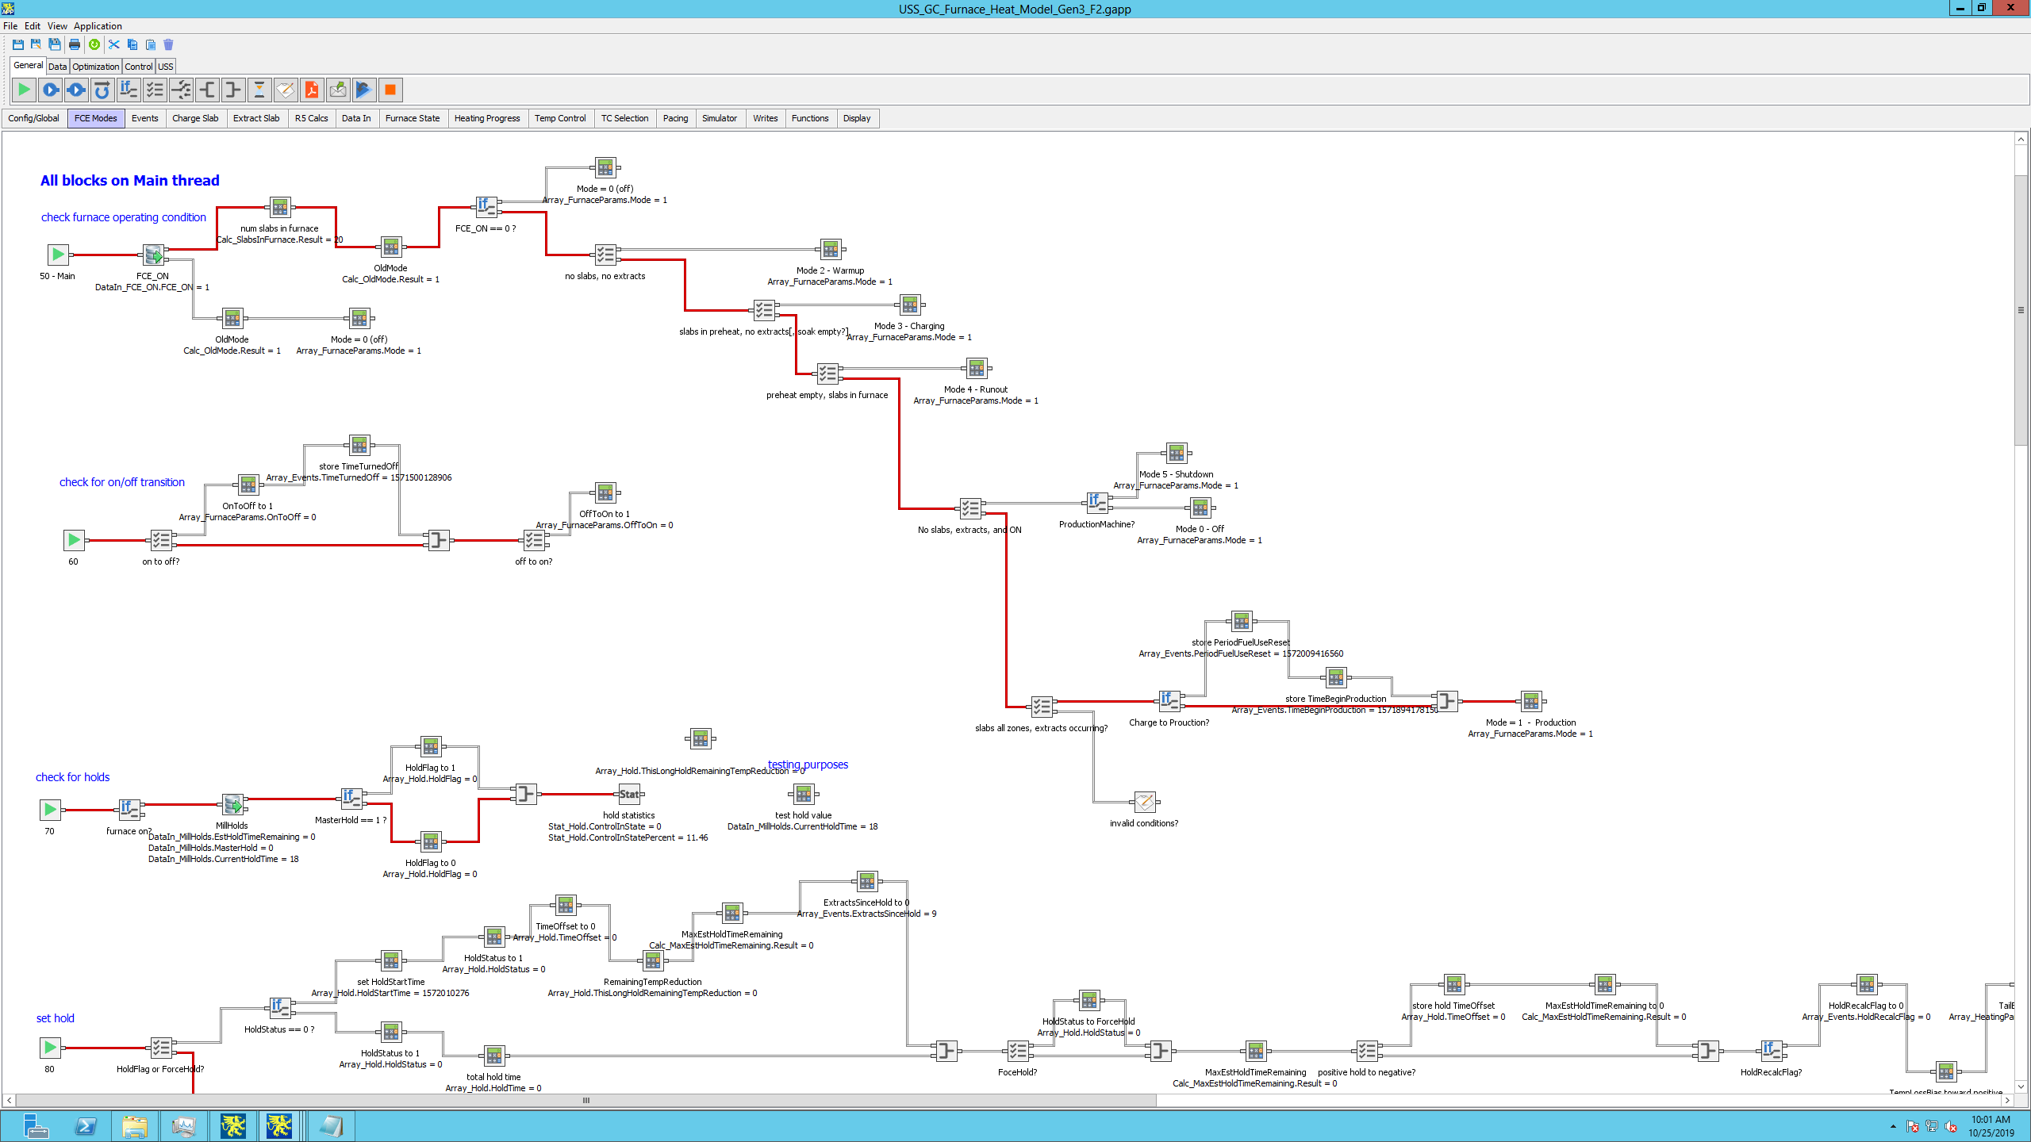

Example of application logic from the Griffin graphical programming environment. Logic can be added, removed, or transformed in any way and redeployed without interruption of control. While applications are running, the execution path is highlighted in red.

Advanced Sensor and Process Modeling

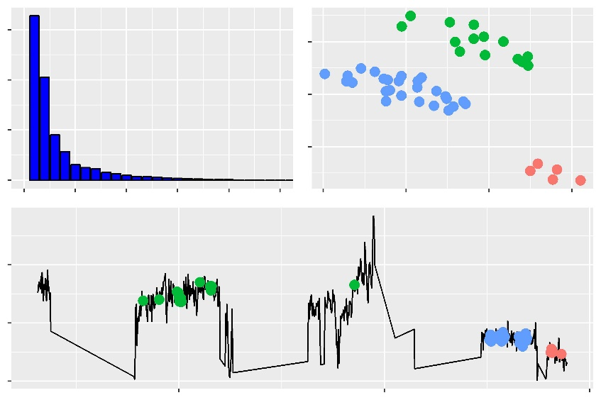More sophisticated fault detection relies on creating a model to predict the value of a given output across operating conditions. These models can be statistical, such as with MSET or PCA, or based on models such as neural networks. The high sensitivity of MSET leads to many false positives, so expect to implement additional alarm processing when applying that method. The newly developed PCA monitoring tools within the Griffin Toolkit® are insensitive to noisy signals and provide the added benefit of condensing highly complicated processes into simply analyzed groupings of uniquely identified process conditions (system failure progression and identifying factors shown at right). Neural networks in the Griffin Toolkit® have the advantage of being testable and tunable by the user, and fully integrated into our graphical programming environment. Griffin also provides the Genetic Trainer, a powerful package for automatically searching for the optimal neural network to fit a given dataset.

ID FAN OUT PRESS

MILL 4 HA DMP

MILL 3 AMPS

Once the neural network is trained to predict the process value (using user-curated “good” data), it can be used to predict the current value. When significant deviation is observed, users can be alerted to either a malfunctioning sensor, maintenance issue, or some other type of process problem. This method can be applied to any type of output generated by a plant, including entire groups of outputs simultaneously.

More Information

The Griffin Toolkit® is an easy-to-use process optimization suite with neural networks and evolutionary optimization built in. Griffin is currently being used across industries with a near perfect adoption rate. For more information about how our software can help your business improve equipment maintenance and process control, please visit us online at [www.griffinopensystems.com](http://www.griffinopensystems.com) or send us a message at [info@griffinopensystems.com](mailto:info@griffinopensystems.com).